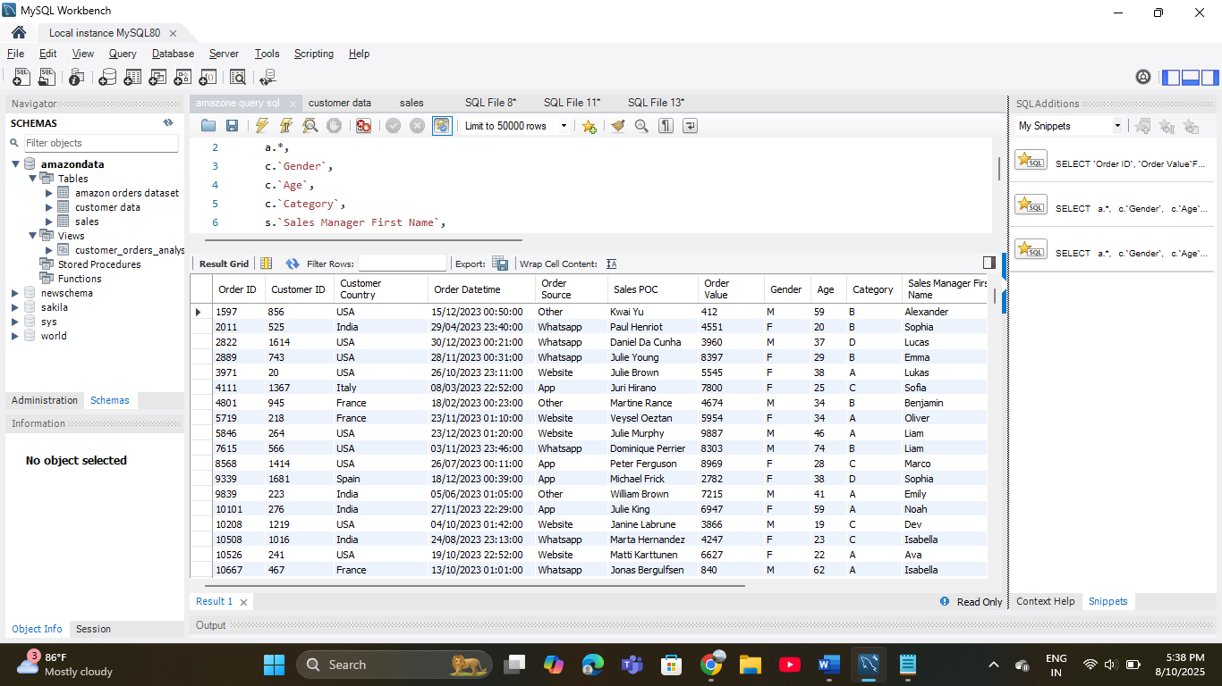 ss

**Table amazon order dataset left join with customer data & sales data**

**SQL QUERY :**

select

a.*,

c.`Gender`,

c.`Age`,

c.`Category`,

s.`Sales Manager First Name`,

s.`Sales Manager Last Name`,

s.`Sales Team`,

s.`2023 Sales Target`

FROM `Amazon Orders Dataset` AS a

LEFT JOIN `customer data` AS c

ON a.`Customer ID` = c.`Customer ID`

LEFT JOIN `sales` AS s

ON a.`Sales POC` = s.`Sales POC`

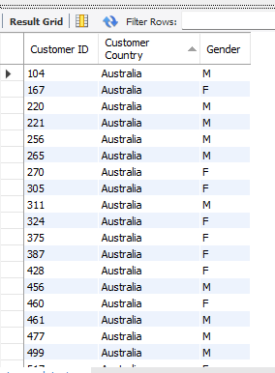

**Customer ID with Order Value >5000**

**SQL QUERY :**

SELECT `Customer ID`, `Customer Country`, `Gender`

FROM `customer data`

WHERE `Customer ID` IN (

SELECT `Customer ID`

FROM `amazon orders dataset`

GROUP BY `Customer ID`

HAVING SUM(`Order Value`) > 5000);

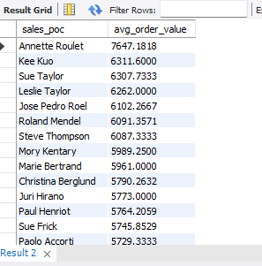

**Average Order Value By Sales POCs**

**SQL QUERY :**

SELECT sales_poc, avg_order_value

FROM (

SELECT `Sales POC` AS sales_poc, AVG(`Order Value`) AS avg_order_value

FROM `amazon orders dataset`

GROUP BY `Sales POC`

) AS sales_avg

ORDER BY avg_order_value DESC;

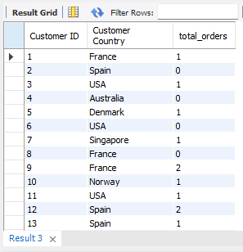

**No. of orders from different countries**

**SQL QUERY :**

SELECT

c.`Customer ID`,

c.`Customer Country`,

(SELECT COUNT(*)

FROM `amazon orders dataset` AS o

WHERE o.`Customer ID` = c.`Customer ID`) AS total_orders

FROM `customer data` AS c;

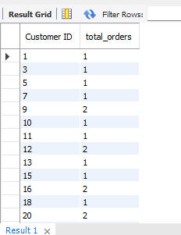

**Total orders for Each Customer**

**SQL QUERY :**

SELECT

`Customer ID`,

COUNT(`Order ID`) AS total_orders

FROM `amazon orders dataset`

GROUP BY `Customer ID`;;

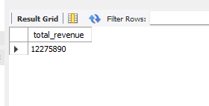

**Total Revenue**

**SQL QUERY :**

SELECT

SUM(`Order Value`) AS total_revenue

FROM `amazon orders dataset`;

**Earliest & Latest Order Date**

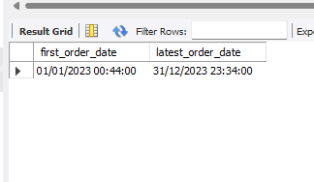

**SQL QUERY :**

SELECT

MIN(`Order Datetime`) AS first_order_date,

MAX(`Order Datetime`) AS latest_order_date

FROM `amazon orders dataset`;

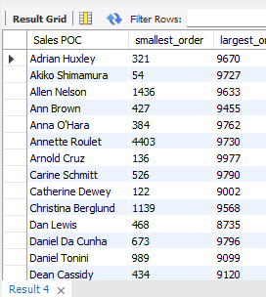

**Smallest Order & Largest Order By Sales POCs**

**SQL QUERY :**

SELECT

`Sales POC`,

MIN(`Order Value`) AS smallest_order,

MAX(`Order Value`) AS largest_order

FROM `amazon orders dataset`

GROUP BY `Sales POC`

ORDER BY `Sales POC`;

CREATE

**Order analysis in view tab**

ALGORITHM = UNDEFINED

DEFINER = `root`@`localhost`

SQL SECURITY DEFINER

VIEW `customer_orders_analysis` AS

SELECT

`o`.`Order ID` AS `Order ID`,

`o`.`Customer ID` AS `Customer ID`,

`c`.`Customer Country` AS `Customer Country`,

`c`.`Gender` AS `Gender`,

`c`.`Age` AS `Age`,

`c`.`Category` AS `Category`,

`o`.`Order Datetime` AS `Order Datetime`,

`o`.`Order Source` AS `Order Source`,

`o`.`Sales POC` AS `Sales POC`,

`s`.`Sales Manager First Name` AS `Sales Manager First Name`,

`s`.`Sales Manager Last Name` AS `Sales Manager Last Name`,

`s`.`Sales Team` AS `Sales Team`,

`s`.`2023 Sales Target` AS `2023 Sales Target`,

`o`.`Order Value` AS `Order Value`

FROM

((`amazon orders dataset` `o`

LEFT JOIN `customer data` `c` ON ((`o`.`Customer ID` = `c`.`Customer ID`)))

LEFT JOIN `sales` `s` ON ((`o`.`Sales POC` = `s`.`Sales POC`)))